Supplementary Materials

Non-Calibrated Model Parameters
Accompanying supplementary materials file parameterDirectory.xlsx provides an in-depth overview of all parameter changes made to the default HPVsim in order to fit to the English setting, alongside sources. Below is a selection of tables from this workbook, for quick reference of key parameters.

Initial HPV prevalence for women by age bracket is informed by WHO data for England (https://hpvcentre.net/statistics/reports/GBR.pdf?t=1667160001618, figure 54). Data for men is informed by USA estimates (https://doi.org/10.1093/infdis/jix057, Figure 2).

Initial HPV Prevalence by Sex and Age Group, over all Genotypes
Age (years) | 0-16 | 17-24 | 25-34 | 35-44 | 45-54 | 55-64 | 65+
Initial Female HPV Prevalence | 0 | 0.25 | 0.14 | 0.08 | 0.06 | 0.06 | 0.03
Initial Male HPV Prevalence | 0 | 0.20 | 0.23 | 0.20 | 0.18 | 0.25 | 0.25

We calibrate the below parameters, with two highly variable depending on social setting (requiring calibration when fitting to the new setting of England), and the beta parameter a core parameter necessitating calibration.
Calibrated Parameters relating to HPV transmission, excluding genotype-specific parameters
Parameter Name | Parameter Interpretation | Prior | Lower Bound | Upper Bound
f cross layer | Proportion of female agents who have concurrent cross-layer relationships | 0.15 | 0 | 1
m cross layer | Proportion of make agents who have concurrent cross-layer relationships | 0.25 | 0 | 1
beta | Per-act probability of HPV transmission | 0.25 | 0 | 0.5

HPV DNA test characteristics are informed by the meta analyses of https://pubmed.ncbi.nlm.nih.gov/26851054/.

Model of HPV DNA test characteristics.
Agent State | Outcome Distribution
 | Positive | Negative
Susceptible | 0.12 | 0.88
Latent | 0.12 | 0.88
Precin | 0.94 | 0.06
CIN | 0.94 | 0.06
Cancerous | 0.94 | 0.06

Cytology characteirstics are informed by analyses in high income settings (https://pmc.ncbi.nlm.nih.gov/articles/PMC6483676/).

Model of Cytology characteristics.
Agent State | Outcome Distribution
 | Normal | Abnormal
Susceptible | 0.96 | 0.04
Latent | 0.96 | 0.04
Precin | 0.96 | 0.04
CIN | 0.3 | 0.7
Cancerous | 0 | 1

Colposcopy. Meta analysis finds senstivity at 0.95 and specificity at 0.42 (https://pubmed.ncbi.nlm.nih.gov/26851054/) - probabilities are based on this. Our modelling only acts on two outcomes from colposcopies - 'hsil' (prompting ablation) or 'cancer' (prompting general cancer treatment) (or 'normal'); accordingly, we assign no probability mass to ascus or lsil. This also agrees with https://doi.org/10.1016/j.ejogrb.2019.07.003 (2nd form of defining colposcopy outcomes used here out of the 2 defined in the paper).

Model of Colposcopy characteristics.
Agent State | Outcome Distribution
 | Normal | Abnormal: HSIL | Abnormal: Cancer
Susceptible | 0.7 | 0.3 | 0
Latent | 0.6 | 0.4 | 0
Precin | 0.42 | 0.58 | 0
CIN | 0.05 | 0.95 | 0
Cancerous | 0 | 0.05 | 0.95

Calibration Results
The parameter samples and associated GOF values arising from calibration are available on the GitHub: https://github.com/fabiansturman/HPVScreeningProject/.

Age brackets are in 5-year intervals: 0-5,5-10, 10-15, etc. Genotypes are 16, 18, hi5, and ohr in that order.

  - Fit to seen data, 2011-2018
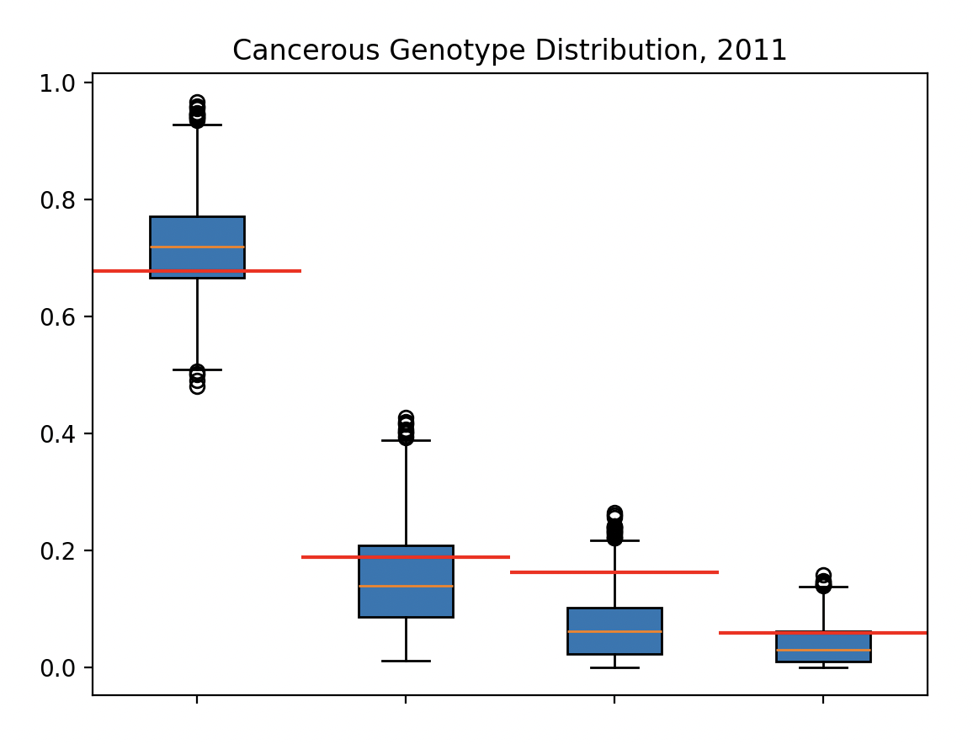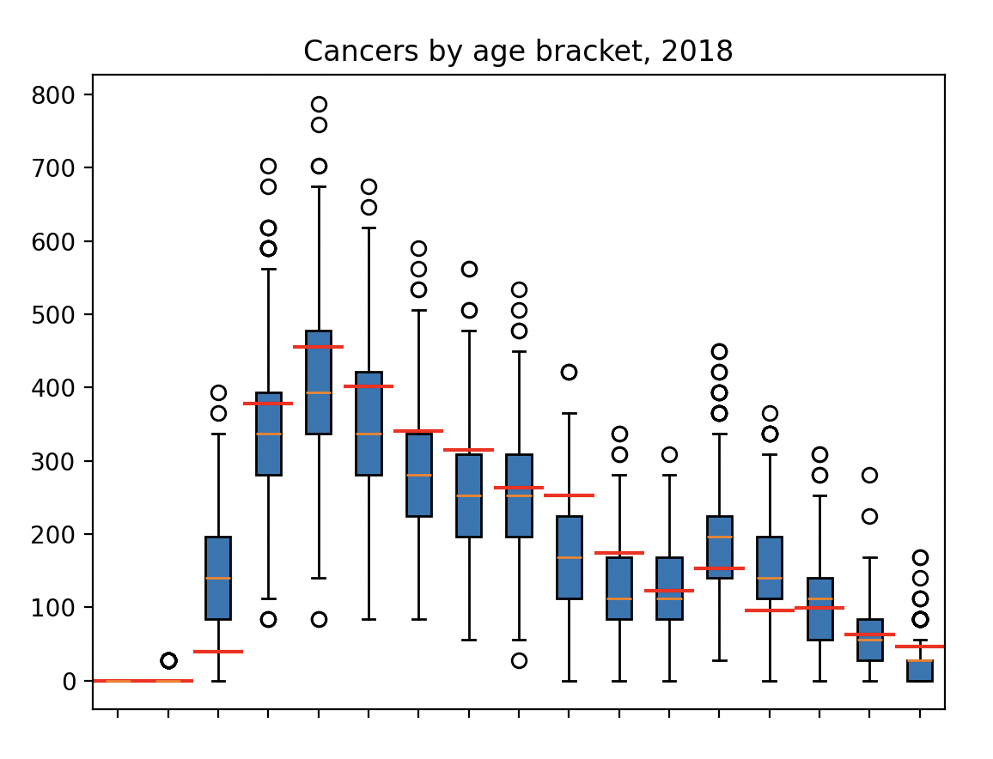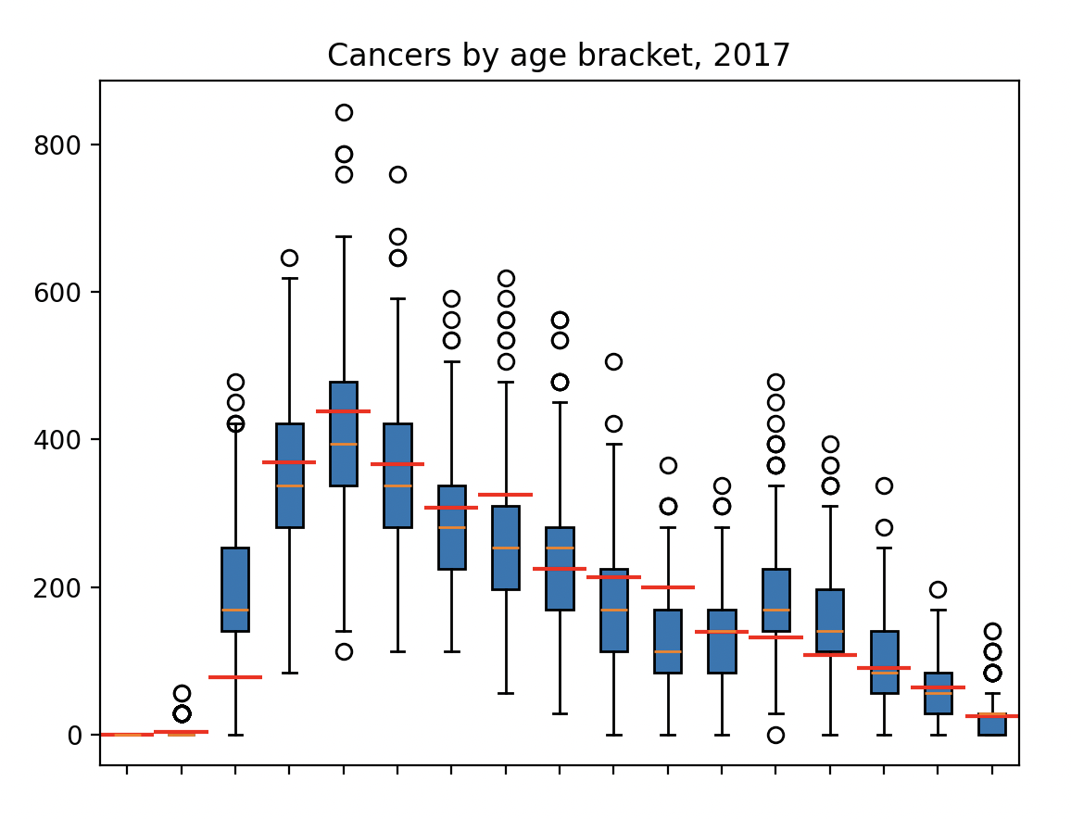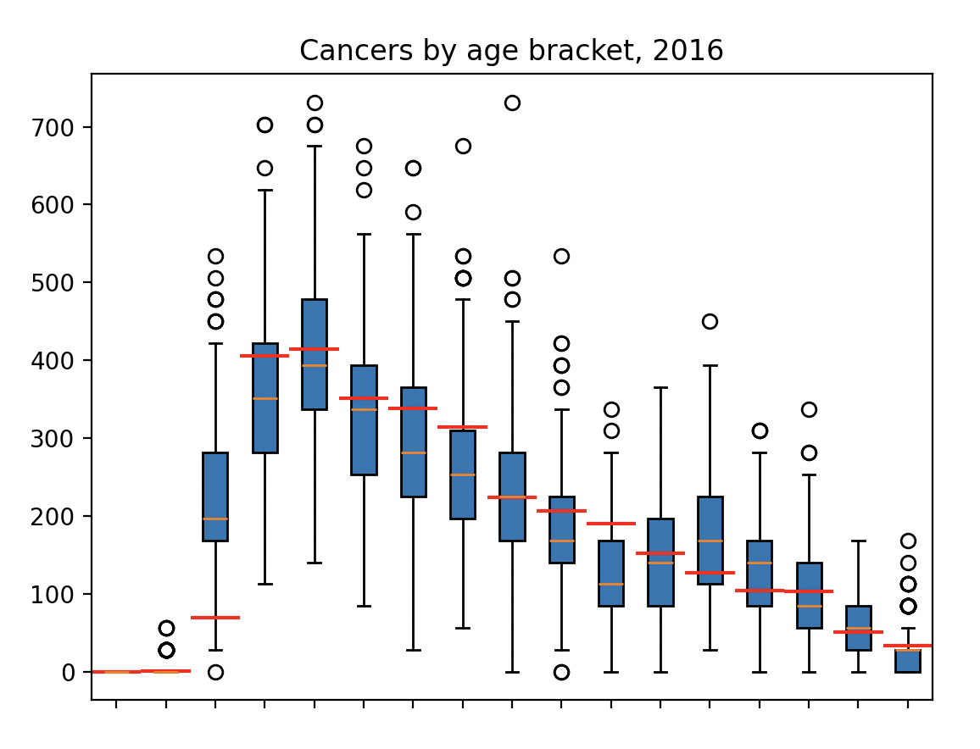
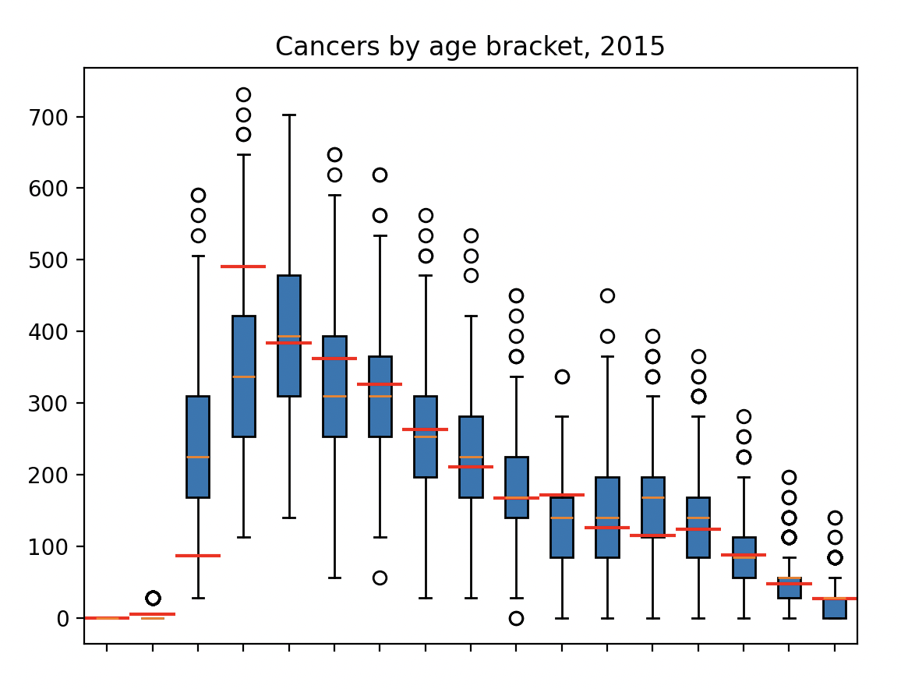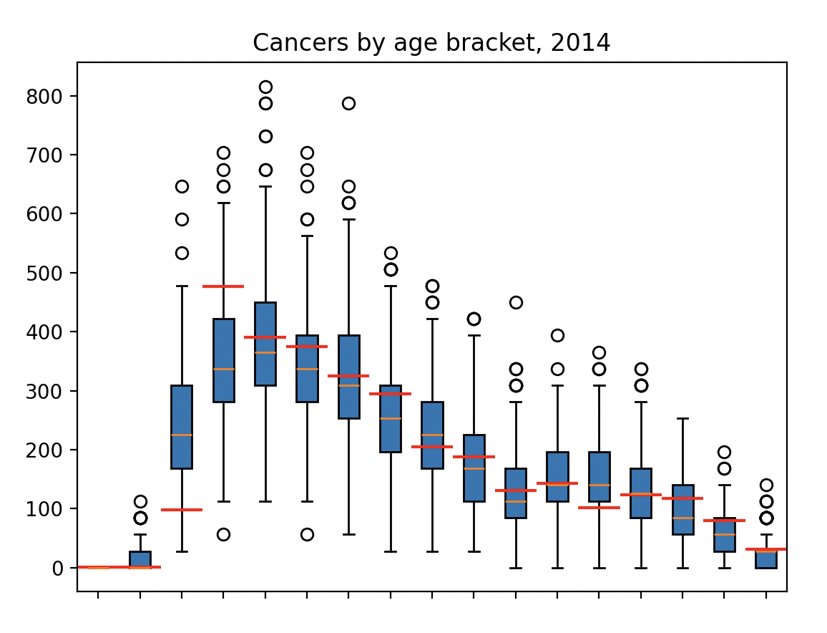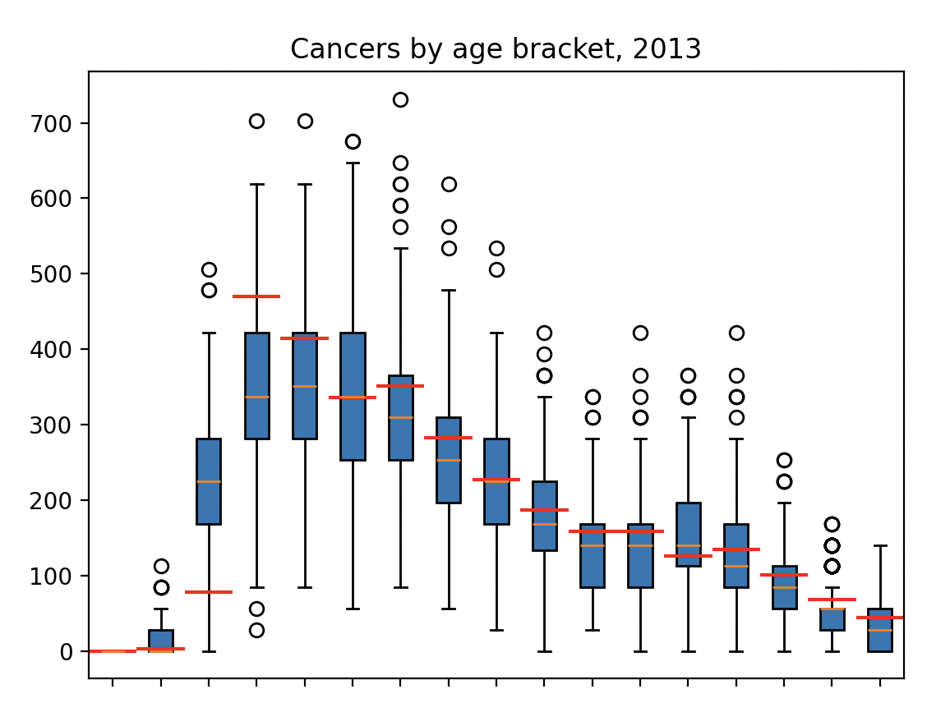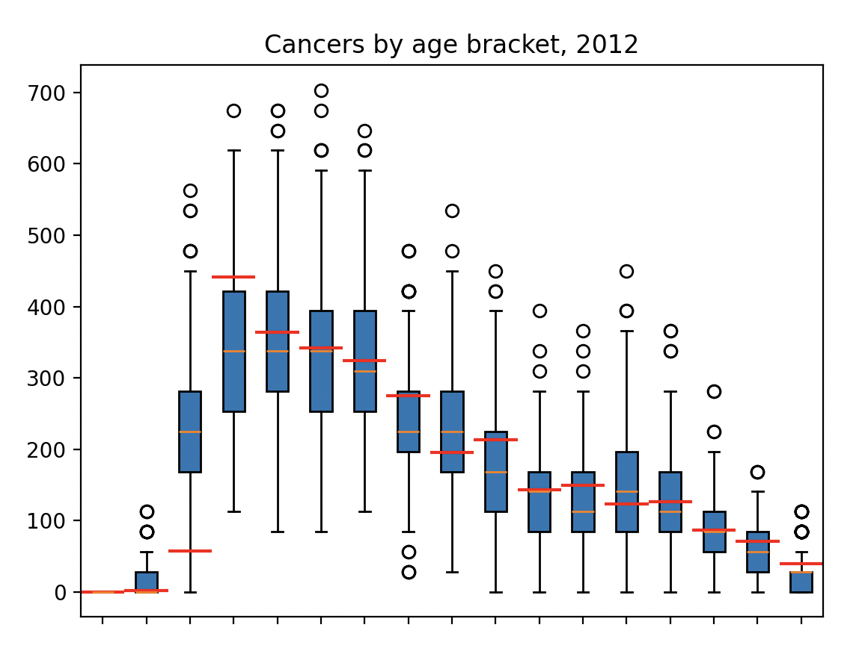

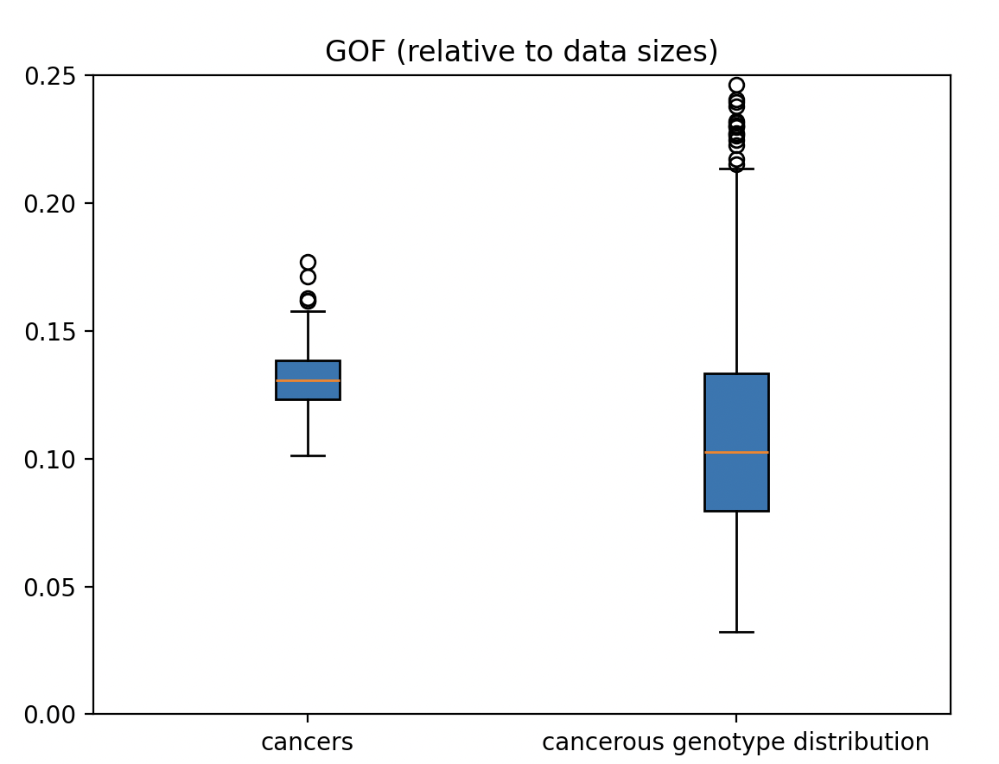
GOF summary:
min:0.15337479591127964
LQ:0.20956726961185193
median:0.23289504774684922
UQ:0.26393707302795955
max:0.3701605036952192

  - Fit to unseen data, 2019-2022
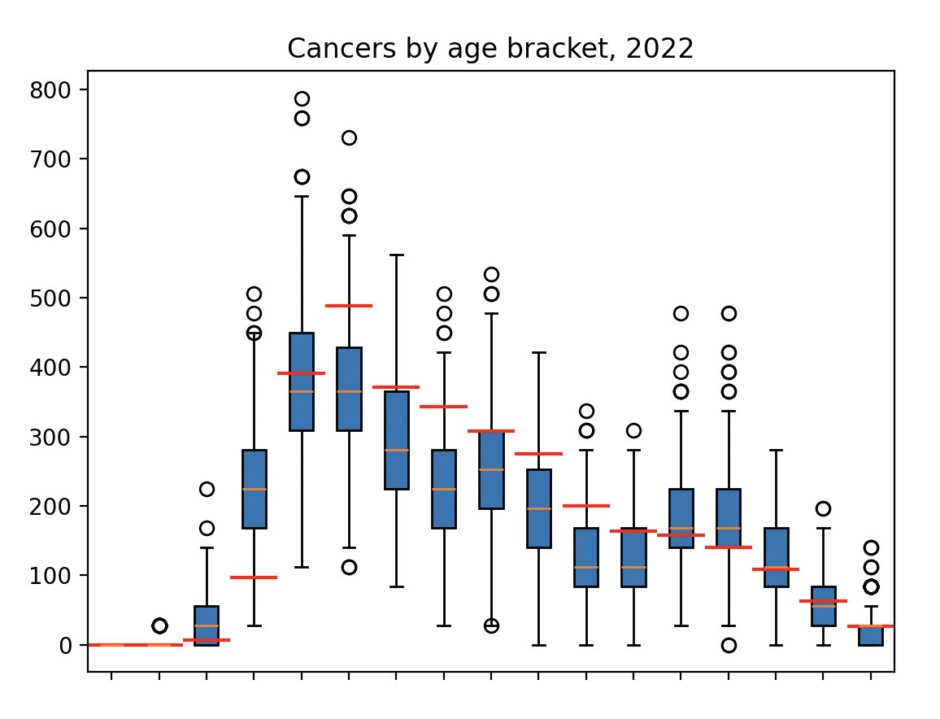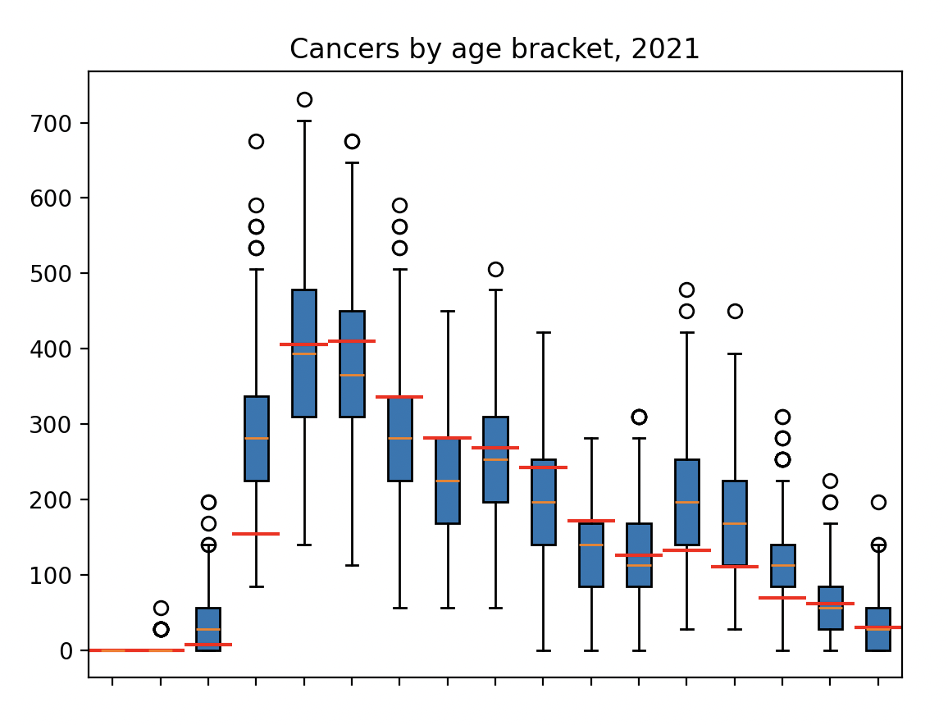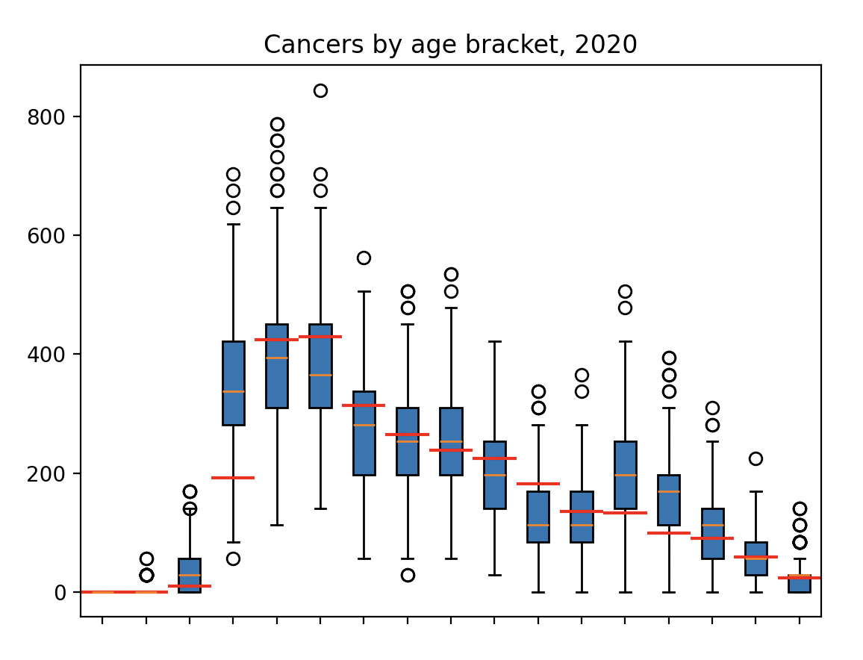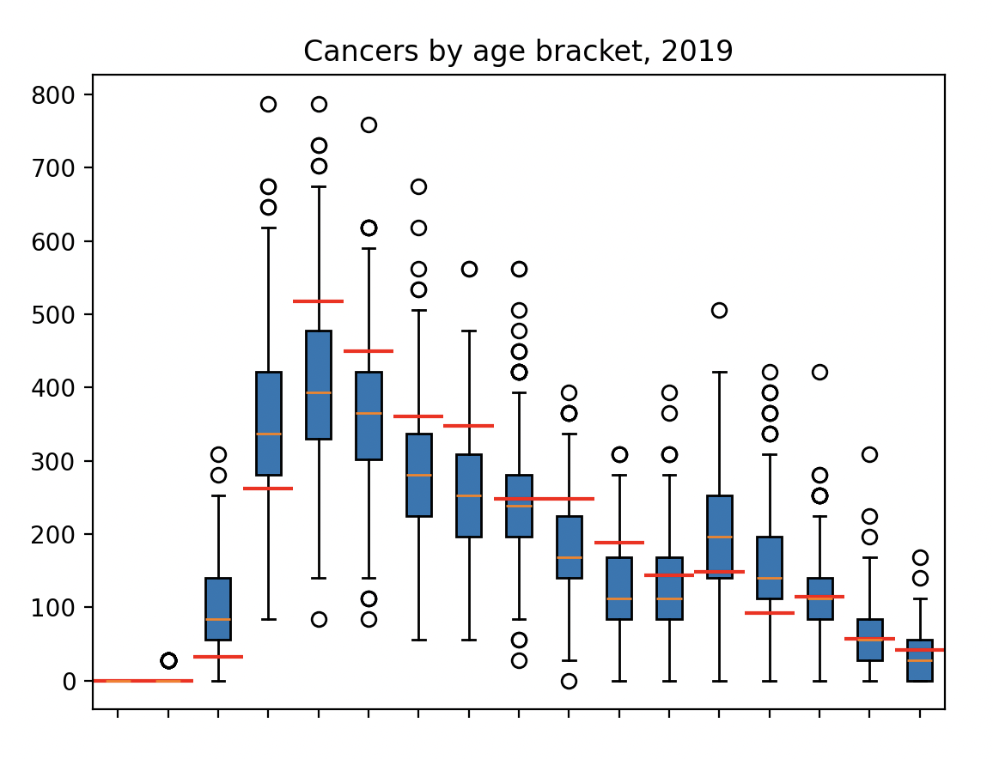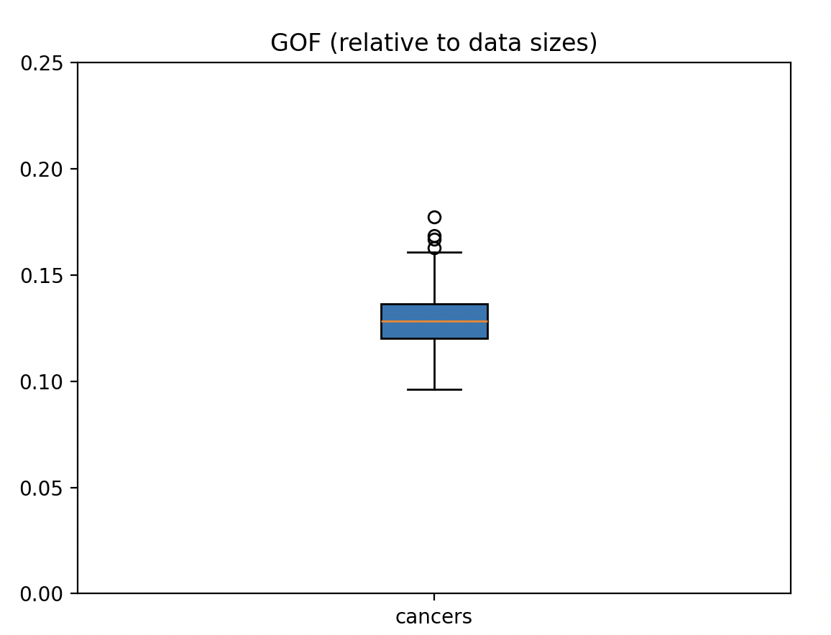
GOF summary:
min:0.0960734212166411
LQ:0.12003104536818687
median:0.1282326212273455
UQ:0.1364154567600706
max:0.17751356001085206

HPV Prevalence
HPV 16 and/or 18 prevalence amongst 16-18, 19-21, and 22-24 year olds, against surveillance data from UKHSA (https://doi.org/10.1016/j.vaccine.2023.10.002). A good fit for 16-18 year olds throughout, with a poorer fit for older age groups due to no modelling of catch-up vaccination in our model causing overestimated prevalence in these groups. However, beyond 2020 our model is re-aligned with HPV cases in these age groups, as at this time individuals born in 1995 who underwent routine HPV vaccination at ages 12-13 will be 25 years old. For analyses which rely heavily on predicting HPV prevalence or cancers amongst the cohort not offered routine vaccination but rather catchup, our model therefore may overestimate prevalence and cancers. However, for longer term projections, due to the temporary nature of this transitionary period, the omission of catch-up screening may be negligible.
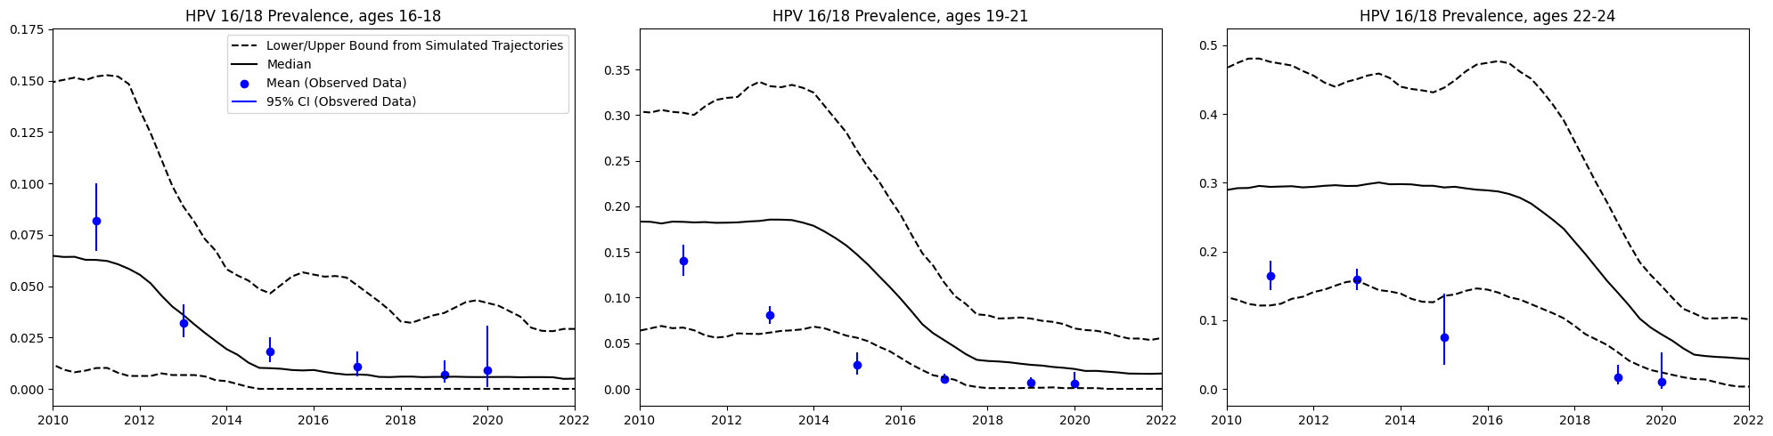

A chart of simulated infection prevalence by age for three annual snapshots shows the effect of vaccine-rollout on HPV 16/18, with reduced cases over the full population in younger ages and over time.

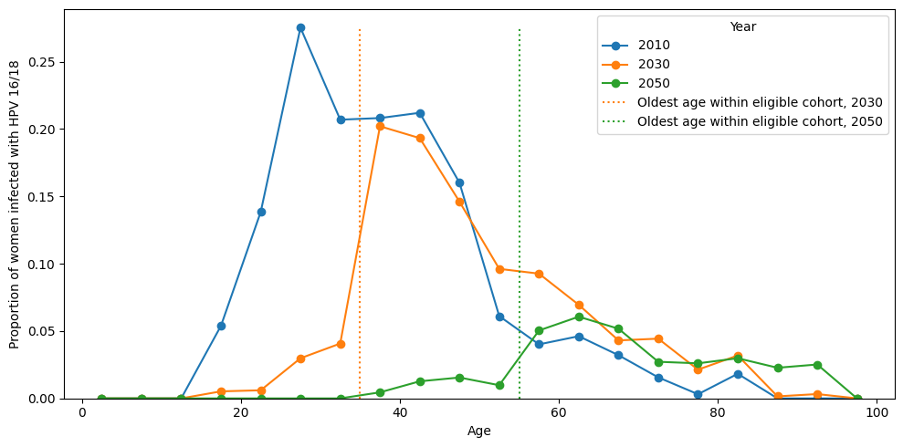
When focussing on the unvaccinated population only, we see a notable herd effect amongst those who are vaccine eligible, with a dampening of infections amongst ages which interact most with vaccinated individuals.
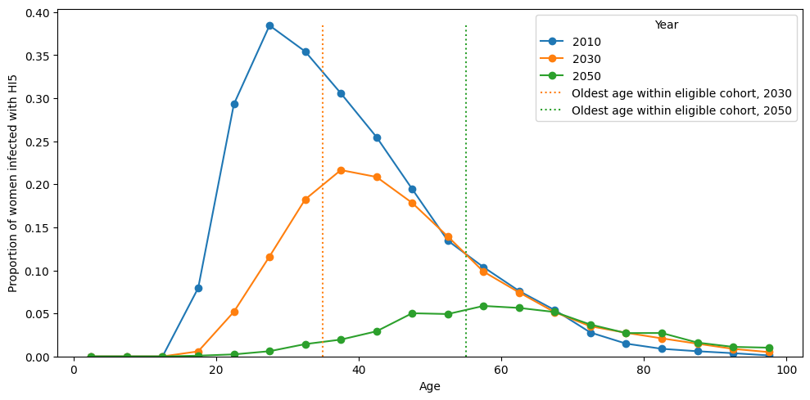

We also observe the effectiveness of the vaccine against the HI5 types also included in the nonavalent vaccine.
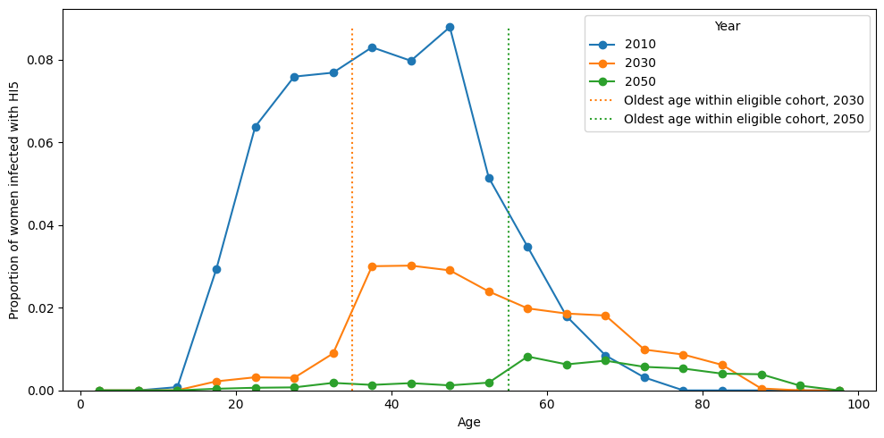

We see that the vaccine has no significant effect on ohr types, in line with our modelling assumption of no cross immunity to these types.
